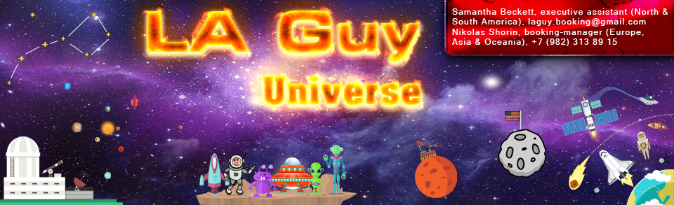

Technical and household requirements, which inviting party must do.

1. Technical rider.

a) Pioneer CDJ 2000 (2 pcs. or more).
b) Pioneer DJM 900 (1 pcs.).
c) Presence a good monitor (ideally will be Mackie SRM450 or DAS AUDIO ROAD 15A), min 300 watt of power, on the right from DJ (better will be on both sides), which reproduces all frequency range and it is connected directly to dj mixer.
d) Microphone radiosystem (radio microphone) exellent quality.
For example: Sennheiser (EW145, EW 165, E800 series), Shure (SLX24, T4A-PB). To him must be attached 2 kit (1 inserted and checked for serviceability) absolutely new! battery.
e) Work place (table) must be min 90 cm height, ready for action, with the free place (40-50 cm minimum) on the right and leftward from equipment.

The all using equipment must be in good (and suitable for an action) condition. In the case of neglect of this requirement, this is leads to the failure of the event, and therefore - to the dismay of the audience. Responsibility with of dj, for operability of equipment in the future, is completely eliminated!

STRICTLY FORBIDDEN produce shoot, record and release (on any carrier!) work of the DJ, without consulting with him or with booking-manager!
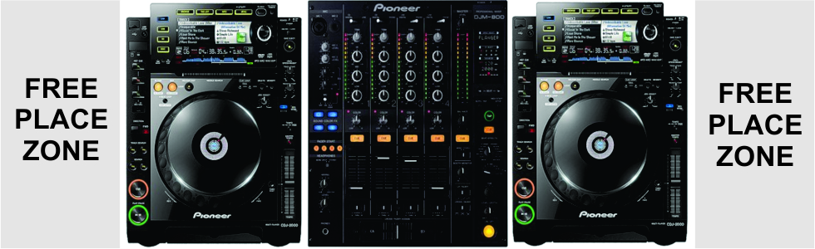
2. Everday raider.

a) Transfer.
Artist can be delivered one of the following methods: Air-flight (economy class or better class), train, bus, auto. Tickets in both directions inviting party buys in advance! (after agreeing with booking-manager), or the inviting party sends the money to buy them. Tickets must be in the hands of a DJ or him booking-manager for 2 weeks before event. Inviting party meets of the Artist at the airport\railway station and is accompanied of the Artist to the place of residence and action. Artist must travel exclusively on comfortable auto not less than of bussines class, with a kit of passenger safety!

b) Inhabitancy.
Residence in comfortable double room (with all the amenities) hotel, with minimum 4* (four stars), in the center of town residence or near with place of carrying out of action of artist on all time of him stay. Hotel must be new or renovated, with non-stop service. Hotel must be pre-approved! The room should be equipped with air conditioning. By opportunity, please keep in mind, that availability of the full mini-bar in the room will brighten residence time of artist, before and after of action, and will show your hospitality . In the case of departure artist out the hotel (in accordance with the approved schedule) after 12 hours of day of local time, the inviting party must EXTEND and PAY full cost of rent of room of artist.
c) Nutrition.
The full nutrition, including beverages, on all time of the artist's stay in the city. Russian, American, Spanish, Brazilian and European food. Time of breakfast, lunch and dinner must be agreed with the artist and him booking-manager. Mineral water (without gas) on all time of action.

d) Special conditions
By the arrival of the artist, makeup room should be ready. The guard of the DJ in club (place of action). In the place of action of the Dj should be ensured absence of unauthorized persons during a DJ set. Photo, video, and interviews must be arranged advance with the booking-manager of the artist.

e) Terms of Payment
Date of action of artist is assigned only after 50% advance payment of inviting party. The remaining 50% paid to the artist for a maximum of 10 days before the date of action. Payment is made only through clearing settlement (through the bank)!

Other requirements.

When non-compliance with any conditions of the rider, artist has the right to refuse performance, leaving himself 50% of the fee, without reimbursement costs of the inviting party. Artist shall not be held responsible for any flight delays by the fault airlines, delays of train, trouble with the car (faults), which occurred through no fault of the artist.

Please read carefully all of the terms of the rider. The all of the points of the rider - must be met! By signing below you are agreeing to comply with all of the terms and requirements of the rider.

Any additional questions and requirements should be discussed with booking-manager, at a more detailed review of your proposal.

The artist and his manager wants express gratitude to you for understanding all the requirements of the rider. We look forward to a successful and mutually beneficial cooperation with you in the future!

Contacts:
Samantha Beckett, executive assistant (North & South America), laguy.booking@gmail.com
Nikolas Shorin, booking-manager (Europe, Asia & Oceania), +7 (982) 313 89 15, laguy.booking@gmail.com

URL:
https://www.facebook.com/LosAngelesGuyOfficial,
https://pro.beatport.com/artist/la-guy/433402,
http://promodj.com/l-a-guy,
https://soundcloud.com/los-angeles-guy

