The technical requirements for the inviting side

The complete DJ-equipment should include the following components (devices):
- CD players: PIONEER (CDJ 800/850/900/1000/2000) - 2 pcs.
- DJ mixer: PIONEER (DJM 600/800/700/2000) – 1 pc.
- The monitor must have a minimum frequency response of 50-18000 hz.
Power must be 300 watts or more, located on the right of the DJ. The monitor must have volume control from dj-mixer.
- Radio microphone of good quality. For example: Sennheiser, AKG, Shure ... The microphone must be connected and controlled directly from the DJ mixer.
- 2 sets of new batteries for the radio microphone.
- Available DJ-mixer connectors:
- REC or MASTER 2 (RCA) for recording.
- FX SEND & FX RETURN (TRS(Jack 3.5”)) for external FX-device.
- Height of the table with the enumerated equipment must be not less than 90 centimeters.
- The places for two laptops, the effector, the pre-amp, the audio interface (the last 2 optional) and 4 power outlet (220 V).
- The equipment and the space for it must be at the following location (3 variants descending preference):
Variant 1
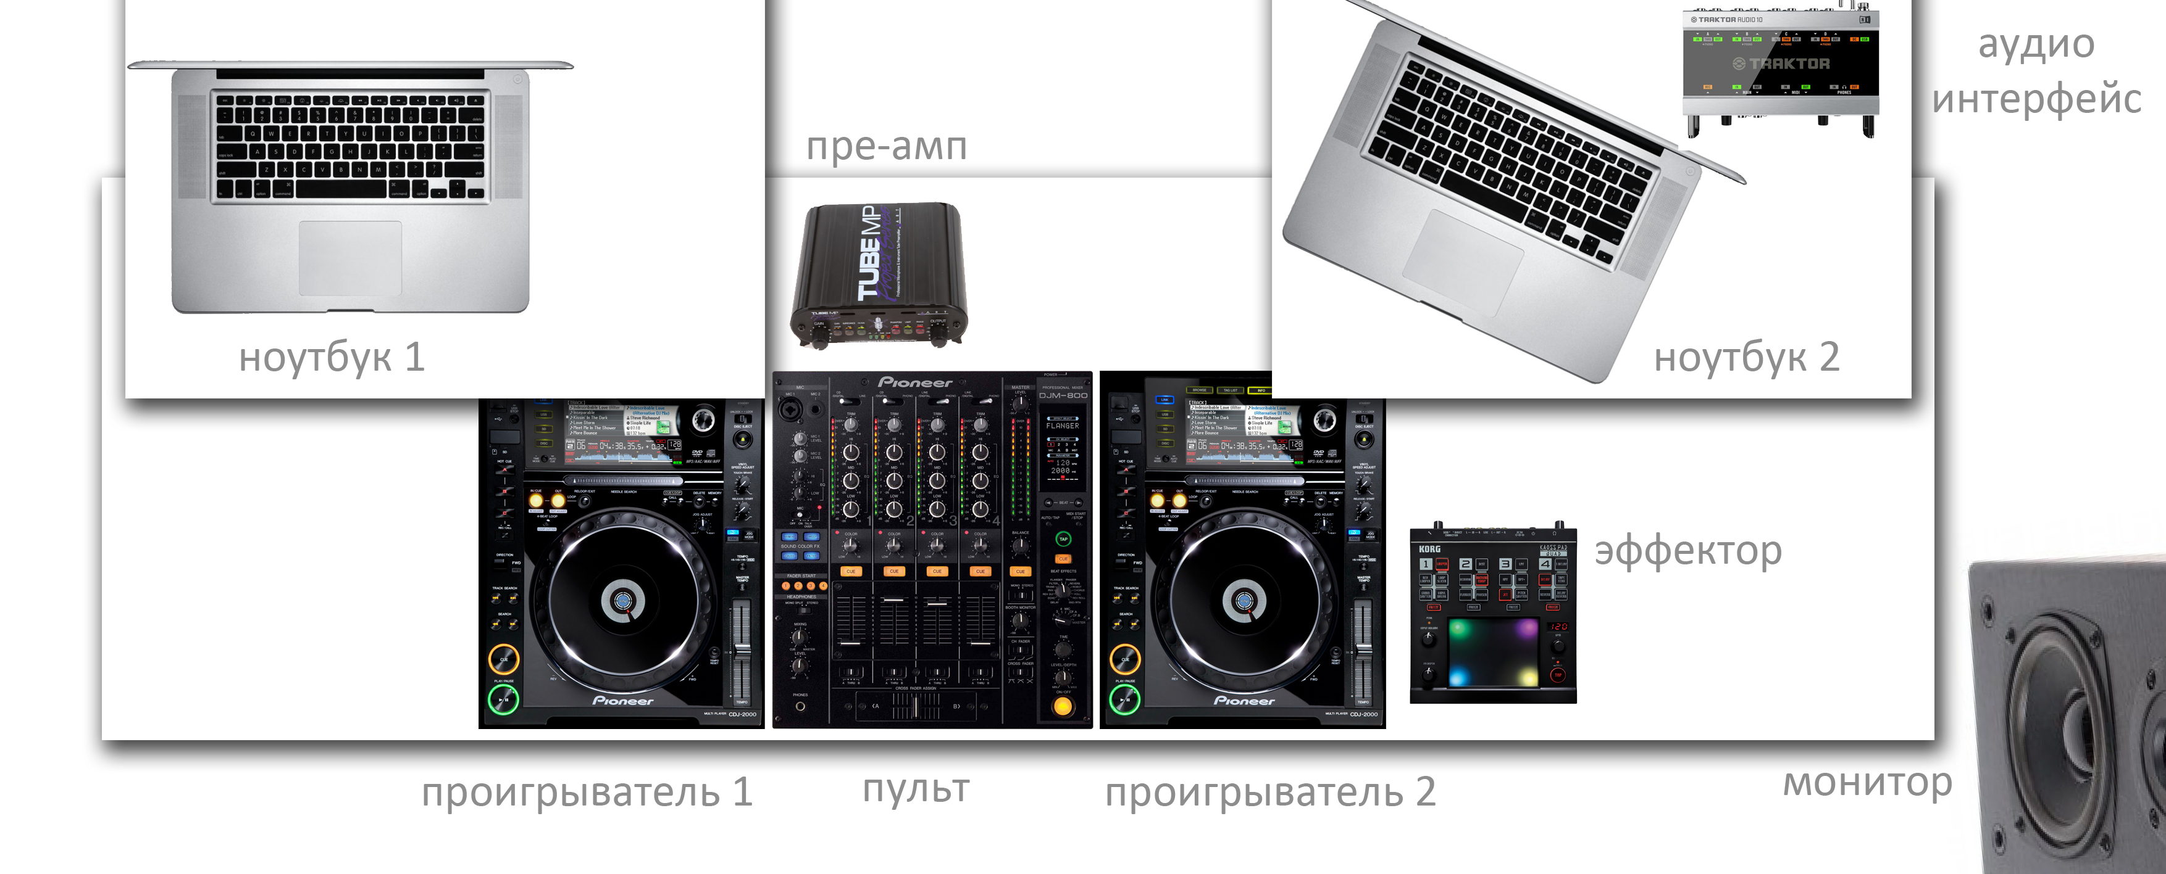
Variant 2
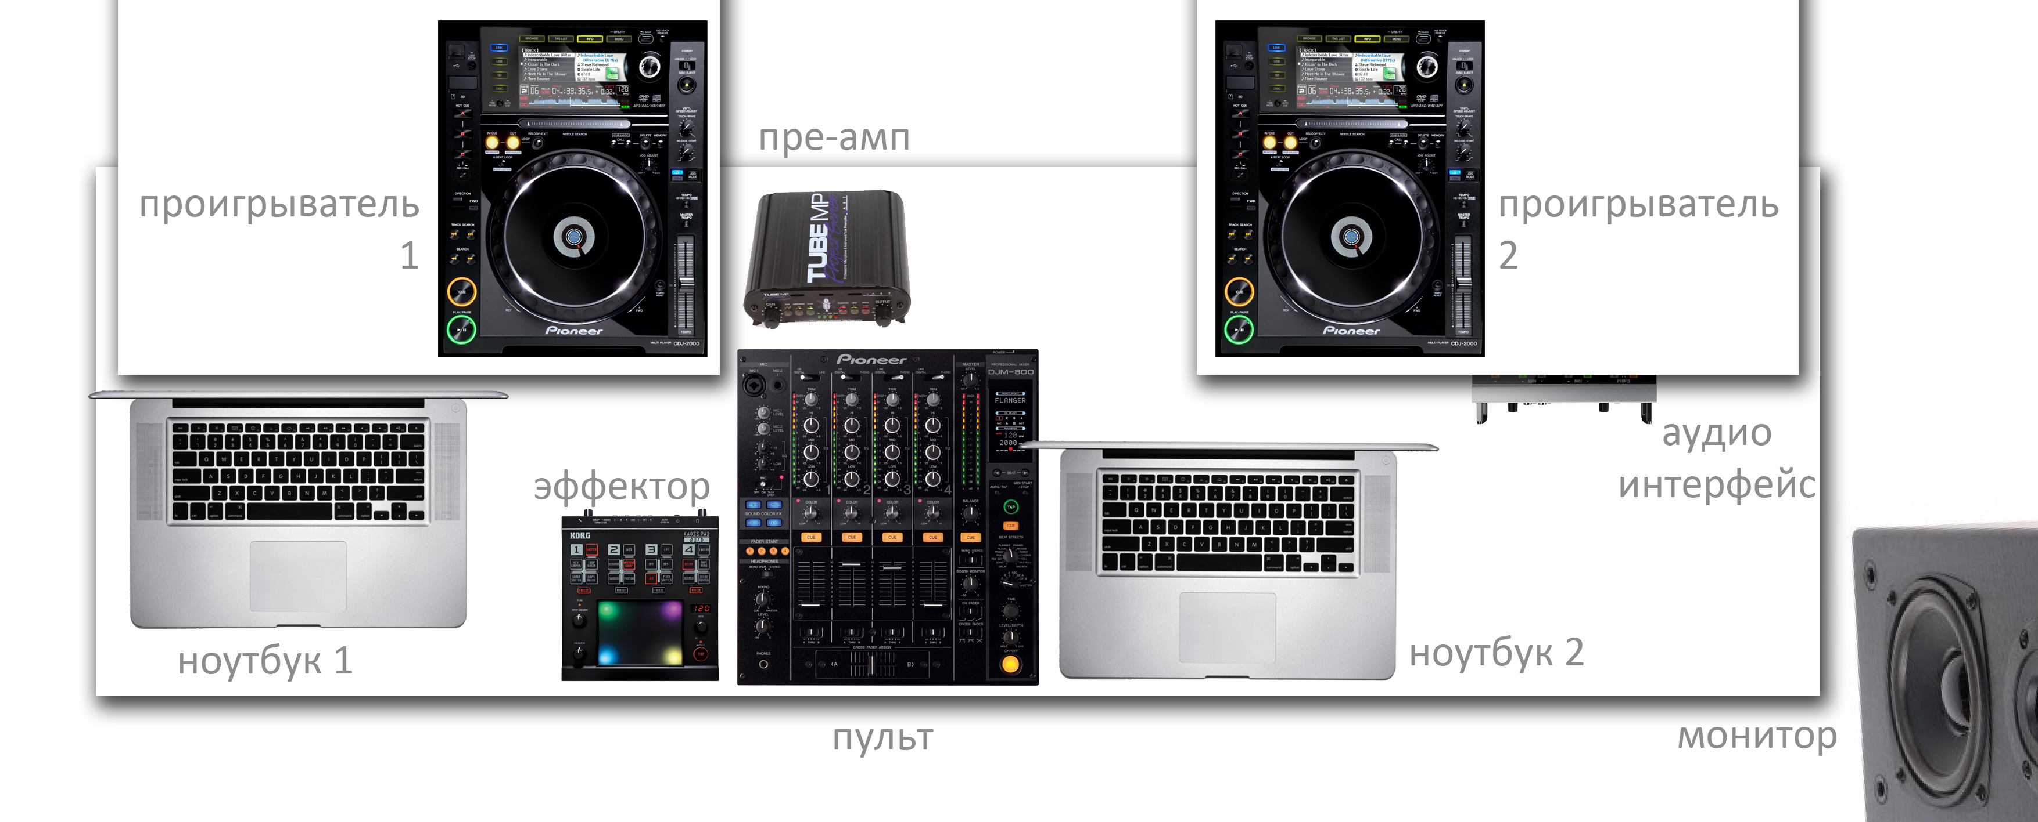
Variant 3
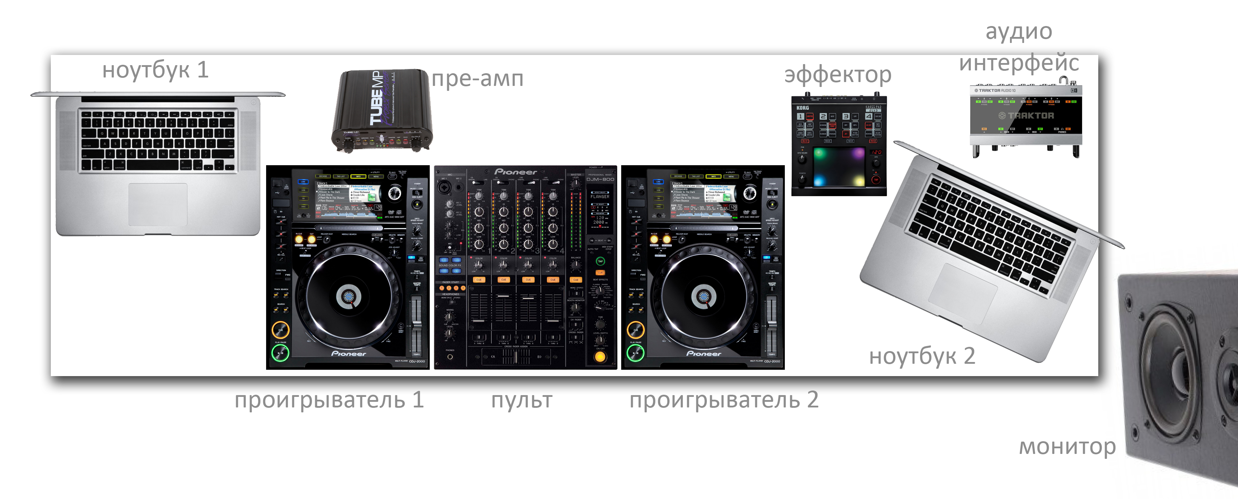

All equipment must be in good and workable condition. In the case of non-compliance with this requirement, for the performance of equipment in the future, the DJ is not responsible!

- Record of the performance. Any record of a DJ-set to any type of media without the permission of DJ or his manager is STRICTLY forbidden! In the case of write permission by the DJ release of the record on any media and distribution on the Internet without the permission of the DJ or the manager are STRICTLY forbidden!

The domestic requirements for the inviting side

The hotel.
There must be one double room with two separate beds or two single rooms, suites or junior suites; category of hotel is not lower than 4 stars. The hotel must be located in the city center or not far from the place of performance. Hotel must be provided for the duration of the stay of the artist in the city.
- The hotel must be clean, new, repaired and without bad smells.
- The rooms should be staffed by air conditioning.
- The service should be available for guests in the rooms within 24 hours.
- If the artist leaves the hotel in accordance with the approved timetable later than 12 pm the customer should extend and pay the extra rent of rooms of the artist.
- Choice of the hotel must be pre-verified.

The club.
Make-up room. The artist should be able to stay before and after the performance in not a smoky room with a lockable door. Make-up room should be at the disposal of the artist. Combining make-up room of the artist with other artists, dancers, technical services, security guards, etc. is not allowed.
During artist's stay in make-up room must be provided:
- soft cold drinks (in sufficient quantity):
- A juice.
- A mineral water.
- one of the alcoholic drinks (in sufficient quantity):
- whiskey Jack Daniels,
- whiskey Jameson.
3) Fruit selection.

The food.
On the whole period of stay of the Artist in the city, promoter should provide and / or pay for the full three meals a day for the artist in a decent restaurant on the choice of the Artist. Food in the cafe economy-class eateries and kebab houses, etc. is not allowed.

==============================================================================
Contacts:
e-mail: jb-booking@ya.ru

URLs:
Johnny Beast on PromoDJ
Johnny Beast on Beatport
Johnny Beast on Soundcloud
Johnny Beast on YouTube
Johnny Beast on Facebook
Johnny Beast on MySpace
Johnny Beast on VKontakte
Johnny Beast's Twitter
Johnny Beast's LiveJournal
Johnny Beast group on VKontakte

